Job Description

Job Title: | PSV Bus Driver (Routemaster)
Hours of Work: | 15 or 16 hours per week/Monday to Sunday on a rota basis. The role is a ‘job share’ role splitting the week between PSV Drivers on a weekly basis.
Department: | Transport
Job Grade: | 8
Accountable to: | Transport Manager
Number of direct reports: | None
Budgetary responsibility: | None
Location: | Stowe School
Purpose of the role: | Driving the Routemaster around the school grounds to the playing fields. The key priorities for a bus driver are the safety of their passengers throughout the journey.
The Stowe Group
The Stowe Group of schools (Stowe, Ashfold, Swanbourne House and Winchester House) is situated on four separate sites in Buckinghamshire and Northamptonshire and educates children from 3-18 years. Within The Stowe Group there are more than 1,800 pupils and 800 members of staff. The schools occupy sites of historical significance in Swanbourne, Dorton, Brackley and the world-famous landscape gardens at Stowe, where we work with The National Trust to manage 880 acres and open the grounds to over 200,000 visitors a year. Stowe House is open to the public during the School holidays and for guided tours during term time. The Stowe Group is committed to safeguarding and promoting the welfare of children and expects all staff to share this commitment. In 2021, The Stowe Group launched its transformational Change Makers vision and Change 100 programme.

Vision & Ethos
We are Change Makers

Stowe stands in the most sublime setting of any school in the world. Historic buildings, landscaped gardens and the very spirit of the Enlightenment sit at the heart of its founding. But, as this remarkable landmark enters its second century as a leading public school, we believe that beauty and tradition are not enough: our future vision for the School embraces change, uncertainty and the challenges that will face our pupils not just during their academic careers, but throughout the rest of their lives in a world which is increasingly complex and ambiguous. Within that volatile environment we see our pupils and staff as Change Makers. They will make a lasting impact not only while they are here at Stowe, but, perhaps more importantly, in the wider world. The history of this place, both as a stately home and as a pioneering school remains important to our mission of education, and at the heart of a Stowe education remains intellectual enquiry, academic curiosity and a love of learning. We strive for a balance of rights and responsibilities, equality and inclusion and to treat each pupil and member of staff as an individual. Our vision is inspired by a history of progressive thinking, and has been developed through collaboration with our pupils, parents, teachers, support staff, governors and alumni. Yes, we teach pupils how to excel in exams, but we also teach them how to collaborate, how to solve problems and how to think critically. Stowe is educating a generation of Change Makers ready to transform the world.

The Group’s talented and committed workforce is one of our greatest strengths. We are committed to fostering team engagement, attracting, mentoring, developing and retaining our best teachers and support staff. We focus on employee wellbeing, provide opportunities for professional growth and we create a culture of community and partnership.

The Stowe Community is committed to working together to achieve Stowe’s aims and objectives. It is a Christian community that aspires to excellence through working efficiently whilst being responsive to change, adding value where possible and using resources wisely.
Key Tasks:
Be aware of and always respect all traffic laws/legislation.
Responsible for carrying out daily and weekly routine vehicle checks, and minor maintenance checks to ensure the vehicle remains roadworthy.
Consistent and safe driving at all times.
Cleaning of the vehicles, to include clearing litter, sweeping, vacuuming and washing interior of the vehicle as required.
Pick up and drop off Students at the scheduled planned times
Always ensure passenger safety
Other hours for similar duties on other school vehicles may be outside of these times
Ad hoc runs for commercial events or School off site visits by prior agreement.
This job description reflects the present requirements of then post and as duties and responsibilities change/develop, the job description will be revised and be subject to amendment in consultation with the post holder .

Person Specification: The selection of candidates for short-listing will be based on this specification and candidates should bear this in mind when preparing their application and completing the application form
Attributes | Essential | Desirable
Qualifications | - Good Basic Education to GCSE level  - Category D on drivers’ licence (PSV)  - Driver CPC qualification
Specialist Skills and Experience | - Good Health, Safety & Compliance awareness  - Driving experience  - Familiar with vehicle checking procedures | - Experience driving a vintage Routemaster double decker bus  - Familiar with challenging behaviour of young people  - Dealing with the public  - Knowledge of Safeguarding
Personal Qualities | - Ability to stay calm and challenge poor behaviour in a polite way  - Good communication skills  - Smart but suitable dressed for variety of weather conditions
This job description and Person Specification reflects the present requirements of the post and as duties and responsibilities change/develop, the job description will be reviewed and be subject to amendment in consultation with the post holder
Date Agreed: March 2026

Our Values
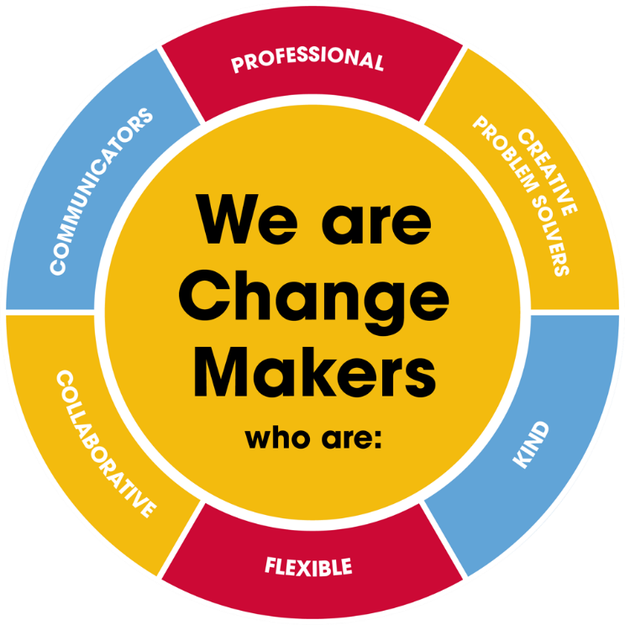
Value scales:
This value is the least important to the role | This value has some significance to the role | This value is desirable to the role but not essential | This value is important to the role | This value is essential to the role
1 | 2 | 3 | 4 | 5

In the role of a Bus Driver we are looking for Change Makers who are (please highlight as appropriate):
Professional: | 1 | 2 | 3 | 4 | 5
Creative Problem Solvers: | 1 | 2 | 3 | 4 | 5
Kind: | 1 | 2 | 3 | 4 | 5
Flexible: | 1 | 2 | 3 | 4 | 5
Collaborative: | 1 | 2 | 3 | 4 | 5
Communicator: | 1 | 2 | 3 | 4 | 5

