Job Description

Job Title: | People Intern
Hours of Work: | Zero Hours Monday to Friday 09.00am – 5.00pm
Department: | People
Accountable to: | Group Head of People
Number of direct reports: | 0
Budgetary responsibility: | N/A
Location: | Stowe
Purpose of the role: | The successful candidate will support the People Department during the course of the summer in various administration activities.
The Stowe Group
The Stowe Group of schools (Stowe, Ashfold, Swanbourne House and Winchester House) is situated on four separate sites in Buckinghamshire and Northamptonshire and educates children from 3-18 years. Within The Stowe Group there are more than 1,800 pupils and 800 members of staff. The schools occupy sites of historical significance in Swanbourne, Dorton, Brackley and the world-famous landscape gardens at Stowe, where we work with The National Trust to manage 880 acres and open the grounds to over 200,000 visitors a year. Stowe House is open to the public during the School holidays and for guided tours during term time. The Stowe Group is committed to safeguarding and promoting the welfare of children and expects all staff to share this commitment. In 2021, The Stowe Group launched its transformational Change Makers vision and Change 100 programme.

Vision & Ethos
We are Change Makers

Stowe stands in the most sublime setting of any school in the world. Historic buildings, landscaped gardens and the very spirit of the Enlightenment sit at the heart of its founding. But, as this remarkable landmark enters its second century as a leading public school, we believe that beauty and tradition are not enough: our future vision for the School embraces change, uncertainty and the challenges that will face our pupils not just during their academic careers, but throughout the rest of their lives in a world which is increasingly complex and ambiguous. Within that volatile environment we see our pupils and staff as Change Makers. They will make a lasting impact not only while they are here at Stowe, but, perhaps more importantly, in the wider world. The history of this place, both as a stately home and as a pioneering school remains important to our mission of education, and at the heart of a Stowe education remains intellectual enquiry, academic curiosity and a love of learning. We strive for a balance of rights and responsibilities, equality and inclusion and to treat each pupil and member of staff as an individual. Our vision is inspired by a history of progressive thinking, and has been developed through collaboration with our pupils, parents, teachers, support staff, governors and alumni. Yes, we teach pupils how to excel in exams, but we also teach them how to collaborate, how to solve problems and how to think critically. Stowe is educating a generation of Change Makers ready to transform the world.

The Group’s talented and committed workforce is one of our greatest strengths. We are committed to fostering team engagement, attracting, mentoring, developing and retaining our best teachers and support staff. We focus on employee wellbeing, provide opportunities for professional growth and we create a culture of community and partnership.
Key Tasks:
- Deliver a scanning project to ensure all files are scanned from paper versions to electronic files.
- Ensure all documents are saved individually and ordered correctly in each file so they can be clearly obtained when necessary.
- Ensure an inventory of all files scanned is updated daily.
- Ensuring papers are disposed of confidentially.
- Supporting the People Team department with any other administration tasks.

Person Specification: The selection of candidates for short-listing will be based on this specification and candidates should bear this in mind when preparing their application and completing the application form
Attributes | Essential | Desirable
Qualifications | - Proficient in IT packages such as MS Word and Excel  - A Levels or Degree | - Knowledge of Sharepoint
Specialist Skills and Experience | - Ability to communicate effectively  - Exceptionally good attention to detail | - Good with data
Personal Qualities | - Able to maintain a high level of confidentiality  - Methodical  - Reliable  - Commitment to Safeguarding  - Ability to work at pace
This job description and Person Specification reflects the present requirements of the post and as duties and responsibilities change/develop, the job description will be reviewed and be subject to amendment in consultation with the post holder
Date Agreed: June 2026

Our Values
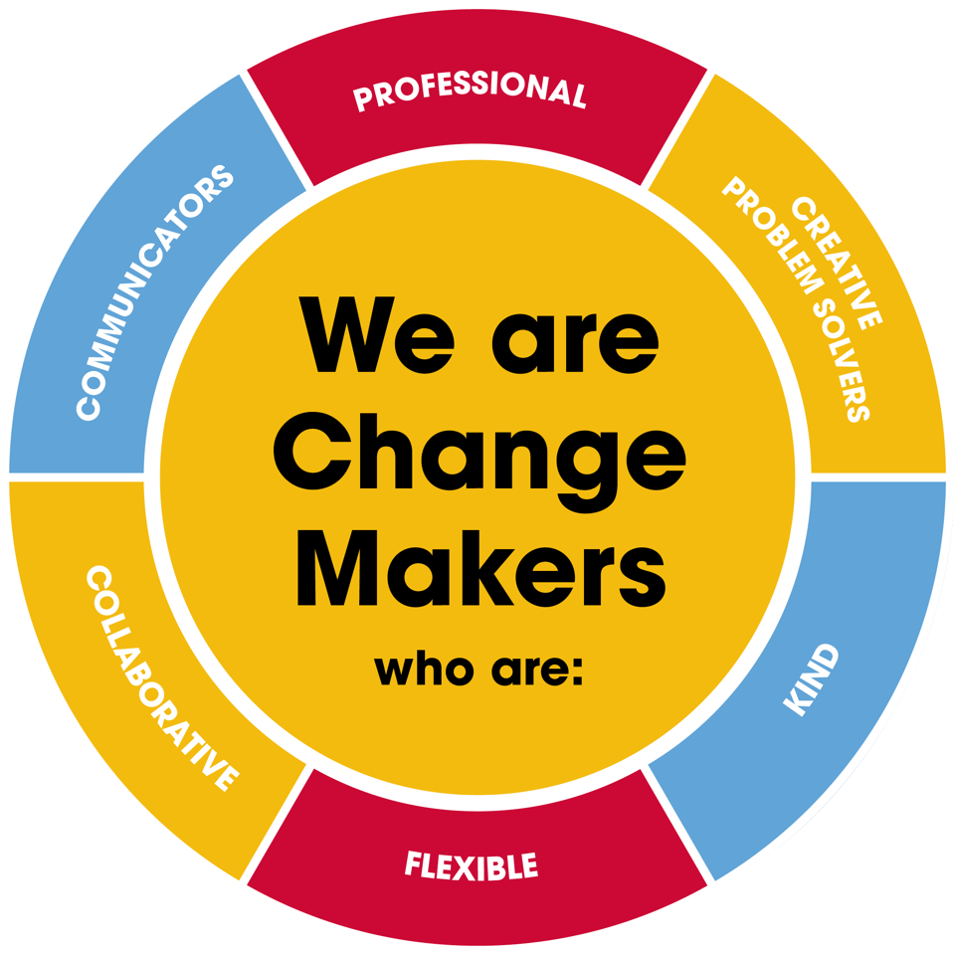
Value scales:
This value is the least important to the role | This value has some significance to the role | This value is desirable to the role but not essential | This value is important to the role | This value is essential to the role
1 | 2 | 3 | 4 | 5

In the role of People Intern we are looking for Change Makers who are (please highlight as appropriate):

Professional: | 1 | 2 | 3 | 4 | 5
Creative Problem Solvers: | 1 | 2 | 3 | 4 | 5
Kind: | 1 | 2 | 3 | 4 | 5
Flexible: | 1 | 2 | 3 | 4 | 5
Collaborative: | 1 | 2 | 3 | 4 | 5
Communicator: | 1 | 2 | 3 | 4 | 5

