Job Description

Job Title: | Housekeeping and Accommodation Manager
Hours of Work: | 37.5 per week, 8am until 4pm Monday to Friday, with occasional out of hours
Department: | Support Services
Job Grade: | 3
Accountable to: | Group Director of Estates
Number of direct reports: | Housekeeping Supervisors x 2  Laundry Supervisor x 1
Budgetary responsibility: | Housekeeping Budgets x 2 as annually advised
Location: | Stowe School  Potential to work on a temporary basis at the Prep Schools depending on business requirements.
Purpose of the role: | The Housekeeping and Accommodation Manager is responsible for the safe and efficient delivery of housekeeping, laundry and staff accommodation services to Stowe School, ensuring that service, budget and programme objectives are achieved and that all relevant legislation and best practice is followed.  They will manage a team of housekeepers (circa 75 staff), supplying a high-quality, cost-effective cleaning and housekeeping service across the school throughout the year, for all activities and uses of the school.  They will manage the in-house laundry service, to ensure a smooth and professional service delivery.  They will manage the delivery of the staff accommodation service (circa 70 accommodation units), supplying a professional service, ensuring statutory compliance and customer support, including interim inspections and the issue and management of occupancy agreements.  They will manage external contractors supplying window cleaning, pest control, sanitary waste hygiene, and other cleaning services to the school.  They will form part of the Stowe Support Services team as per the organogram below:
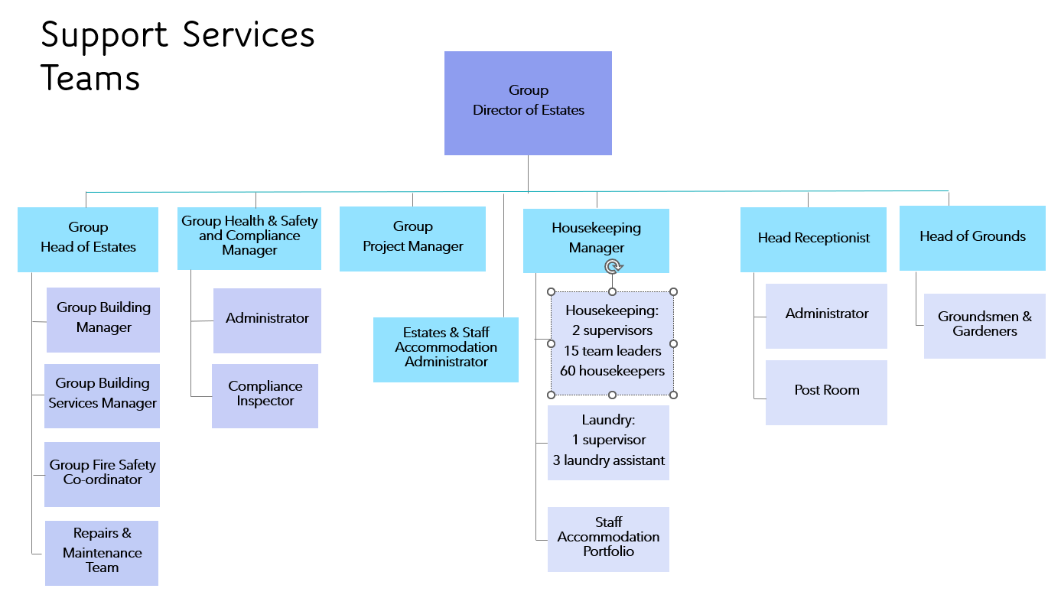

The Stowe Group
The Stowe Group of schools (currently Stowe, Swanbourne House, Winchester House and Ashfold School) was created in January 2021 and is situated on four separate sites in Buckinghamshire and Northamptonshire. Across the schools, The Stowe Group offers education for boys and girls from 3-18 years. Within The Stowe Group there are more than 1,500 pupils and 850 colleagues. The Schools occupy sites of historical significance in Swanbourne, the market town of Brackley and the world-famous landscape gardens at Stowe, where we work with The National Trust to manage 880 acres and open the grounds to over 200,000 visitors a year. Stowe House is open to the public during the School holidays and for guided tours during term time. The Stowe Group is committed to safeguarding and promoting the welfare of children and expects all staff to share this commitment. In 2021, The Stowe Group launched its transformational and substantive Change Makers vision and Change 100 programme

Vision & Ethos
We are Change Makers

Stowe stands in the most sublime setting of any school in the world. Historic buildings, landscaped gardens and the very spirit of the Enlightenment sit at the heart of its founding. But, as this remarkable landmark enters its second century as a leading public school, we believe that beauty and tradition are not enough: our future vision for the School embraces change, uncertainty and the challenges that will face our pupils not just during their academic careers, but throughout the rest of their lives in a world which is increasingly complex and ambiguous. Within that volatile environment we see our pupils and staff as Change Makers. They will make a lasting impact not only while they are here at Stowe, but, perhaps more importantly, in the wider world. The history of this place, both as a stately home and as a pioneering school remains important to our mission of education, and at the heart of a Stowe education remains intellectual enquiry, academic curiosity and a love of learning. We strive for a balance of rights and responsibilities, equality and inclusion and to treat each pupil and member of staff as an individual. Our vision is inspired by a history of progressive thinking, and has been developed through collaboration with our pupils, parents, teachers, support staff, governors and alumni. Yes, we teach pupils how to excel in exams, but we also teach them how to collaborate, how to solve problems and how to think critically. Stowe is educating a generation of Change Makers ready to transform the world.

The Group’s talented and committed workforce is one of our greatest strengths. We are committed to fostering team engagement, attracting, mentoring, developing and retaining our best teachers and support staff. We focus on employee wellbeing, provide opportunities for professional growth and we create a culture of community and partnership.

Key Tasks:
Key Responsibilities and Responsibilities:

General

- To manage a team of housekeepers, team leaders and supervisors to provide a comprehensive cleaning, housekeeping service across the site for the school and events, including cleaning, tidying, bed making (external events), curtain changes and deep cleaning.

- To manage a team of laundry assistants and supervisor to provide a comprehensive laundry service across the site for the school and events.

- To work with the Estates and Staff Accommodation Administrator to provide a comprehensive and statutorily complaint staff accommodation service, including liaison with occupants and stakeholders, working with the Estates team to ensure the upkeep of the portfolio, interim inspections and the issue and management of occupancy agreements.

- To monitor and manage the external contractors relating to provision of a housekeeping service, including but not limited to window cleaning, sanitary waste, pest control, matting and other cleaning activities.

- To support the Group Director of Estates to ensure that the Stowe Estate is maintained to a very high standard, and to provide high quality services to all members of the Stowe Group Community.

- To be an active member of the Support Services Teams

- Work with stakeholders, statutory authorities, the local authority, the National Trust and other third parties in a collaborative manner, attend meetings with the same as required

- To carry out all work in a professional manner, and fully in accordance with the appropriate standards and legislation

Management

- To support, manage and supervise the Housekeeping and Laundry Teams to ensure that in the areas of service responsibility, the Stowe Estate is kept fully maintained to a high level of presentation and statutory compliance, and that all works are cost effective and undertaken within agreed programmes.

- Ensure that department risk assessments are kept up to date and relevant, and that the risk assessment process is fully adhered to.

- To undertake daily work briefings with the housekeeping and laundry teams, ensure that safe work practices and all relevant processes and procedures are always undertaken.

- Ensure that the Housekeeping and Laundry Teams operate fully in compliance of all Stowe Group Policies, including but not limited to Asbestos, Fire Safety and Safeguarding.

- Assist the Group Director of Estates with the preparation and submission of written and financial reports as required.

- Assist the Group Director of Estates to liaise with statutory bodies and provide information as required to ensure statutory compliance

- Develop Term Contracts for suppliers, procurement and analysis of the same, and annual reviews in respect of service delivery matters.

- To ensure that all statutory inspection, processes and procedures are undertaken by the teams and correctly recorded.

- Ensure that statutory compliance and best practice is always fully maintained.

- Undertake appraisals, set and review objectives for the direct reports and assist the supervisors on the same.

- Manage any arising performance and conduct issues and provide support to the supervisors and team leaders for the same.

- Oversee the training matrix for the housekeeping and laundry teams, review all training needs and ensure that training requirements are maintained.

- Assist the Building Maintenance team in ensuring that the legal provisions relating to Health and Safety at work are properly adhered to, including the safe storage of any flammable/toxic substances on site

- Liaise with maintenance and product suppliers as required.

- To use as effectively as possible ICT and be open to developing new ICT strategies to improve efficiency.

- To propose solutions for energy and financial efficiency and improvements in conjunction with service delivery responsibilities

- To provide managerial cover to the supervisors for holidays and sickness

- To attend Operational Meetings as arising, provide reports for the same as required

- Ensure the security of building and the access to keys is controlled and always maintained.

Housekeeping & Laundry

- To oversee the rota of housekeepers and laundry colleagues, ensuring effective cover in case of absences. Ensure the workforce is flexible and able to adjust to changing needs in terms of service delivery.

- Recruitment, training, development and management of colleagues within the department, in line with the school’s HR policies and procedures.

- Oversee stock control, ordering and reporting of chemicals and any goods/services needed for the provision of the service.

- Document cleaning and laundry schedules to ensure consistency of standards and manage expectations in terms of service delivery and frequency. Regularly review with the supervisors to ensure relevance and to respond to changing priorities.

- Maintain a system of Quality Control/Assurance and report on the results, following up on the corrective action needed.

- Oversee the administration of hours/holidays/absence, reporting to finance for payroll purposes to meet the deadlines for correct payroll processing.

- Supply a service to Stowe Enterprise Ltd, preparing areas of the school as needed to support the letting of the premises for events.
- With the supervisors keep all machinery and equipment in good working order, have a robust system to taking equipment out of service when in need of service/repair. Maintain an asset register of equipment and machinery in the department. Have overall responsibility for this process

- Supervision of workforce and manage a system of checking standards, ensuring that any shortfalls in service delivery or building defects are dealt with promptly or reported to the correct department for action.

- Work closely with the laundry supervisor to ensure the continuity of service both in and out of term times is maintained and meets the demand.

- Be on hand and prepared to provide hands on support to the teams at times of need, including occasional weekend support and for Speech Day and other significant events.

Staff Accommodation
- With support from the Estates and Staff Accommodation Administrator oversee and manage the safe delivery of the staff accommodation portfolio (circa 70 units of accommodation). Have overall responsibility for these processes.

- To be the point of contact for occupants and to work with the Estates and Staff Accommodation Administrator to resolve queries and arising issues. Have overall responsibility for this process.

- To ensure that all occupants are in possession of an occupancy agreement and ensure that these are annually reviewed and signed, including provisions for pets.

- Ensure that the occupants comply with the occupancy agreement and work with them to resolve any issues of non-compliance / disputes.

- With the Estates and Staff Accommodation Administrator work with the Estates team to ensure that the staff accommodation is well maintained and statutorily compliant. Have overall responsibility for this process.

- With the Estates and Staff Accommodation Administrator carry out commencement, interim and completion inspections and maintain accurate records. Have overall responsibility for these processes.

- With the Estates and Staff Accommodation Administrator supply a check-in and out service to accommodation occupants, keeping inventory records and validating deposit return claims to HR/Finance. Have overall responsibility for these processes.

- Ensure that the key management process is followed and that the confidentiality of occupants’ personal information is maintained.

Financial

- Oversee and manage budgets as directed by The Group Director of Estates and provide financial reports as requested.

- Have financial accountability for delegated projects, manage budgets and undertake valuations. Keep electronic records, programmes and trackers of all processes and actions

- Ensure that allocated budgets are used effectively across the financial year, and that any potential overspend is notified to the Group Director of Estates in good time.

- Provide financial reports for ELT and Governor meetings as required

Ancillary
- Undertake any other work as reasonably requested by the Head, or the Group Director of Estates.

- On occasions and as required visit one of the Group Prep Schools or off-site properties to aid and support.

- Enrol on the company Grey Fleet and use a company pool vehicle if available, or personal vehicle, provide insurance business cover for the latter. Comply with Stowe driving policies.

- To follow all health and safety instructions for work activities and for using vehicles, plant and equipment if required, report any health and safety concerns or faults immediately to the designated manager. Drive the Stowe vehicles as required and adhere to the driving policy.

- To be aware of, and comply with, the policies and procedures relating to safeguarding, health and safety and security.

- Stowe Group is committed to safeguarding and promoting the welfare of children and young people and expects all staff to share this commitment. The post holder’s responsibility for promoting and safeguarding the welfare of children and young persons for whom he/she comes into contact will be to adhere to and always ensure compliance with the Stowe Group’s Child Protection Policy Statement.

- To be available on an ad hoc basis for out of hours support to the housekeeping team and staff accommodation occupants via telephone / email on an as-needed basis.

- Carry out school-based procedures in the event of fire, flood, breaking and entering, accident or major damage

Person Specification: The selection of candidates for short-listing will be based on this specification, and candidates should bear this in mind when preparing their application and completing the application form
Attributes | Essential | Desirable
Qualifications | - Educated to higher education level in a relevant discipline (minimum HND/HNC or equivalent)  - Qualified to work in the UK  - A full, clean driving licence | - BTEC Diploma in supervision/facilities management or equivalent work experience
Specialist Skills and Experience | - Experience of managing a large team of cleaning staff  - Working knowledge of monitoring and managing cleaning/housekeeping standards  - A good knowledge of Health and Safety legislation applicable to the role  - Experience in training, motivating and developing a team.  - Medium/high level of IT skills  - Experience of recruitment and retention of staff | - Experience of working with a residential School/care/hotel environment
Personal Qualities | - Enthusiastic and the ability to motivate others.  - Clean driving licence, able to travel off-site to properties and other schools using own or school vehicles (must have business use insurance)  - Positive attitude towards working flexible hours for self and team.  - Firm approach to compliance with legislation  - Flexible in dealing with welfare of people.  - Excellent all-round organisational skills.  - Please note this role is physical and involves some heavy lifting, site walking and standing for a large proportion of the day
This job description and Person Specification reflects the present requirements of the post and as duties and responsibilities change/develop, the job description will be reviewed and be subject to amendment in consultation with the post holder
Date Agreed: March 2026

Our Values

Value scales:
This value is the least important to the role | This value has some significance to the role | This value is desirable to the role but not essential | This value is important to the role | This value is essential to the role
1 | 2 | 3 | 4 | 5

In the role of Housekeeping and Accommodation Manager we are looking for Change Makers who are (please highlight as appropriate):

Professional: | 1 | 2 | 3 | 4 | 5
Creative Problem Solvers: | 1 | 2 | 3 | 4 | 5
Kind: | 1 | 2 | 3 | 4 | 5
Flexible: | 1 | 2 | 3 | 4 | 5
Collaborative: | 1 | 2 | 3 | 4 | 5
Communicator: | 1 | 2 | 3 | 4 | 5

