Job Description

Job Title: | Visiting Music Teacher - Harp
Department: | Music
Accountable to: | Head of Instrumental Studies and Director of Music
Number of direct reports: | None
Budgetary responsibility: | None
Location: | Stowe School
Purpose of the role: | The successful candidate should be an experienced, enthusiastic and committed teacher with a proven track record of teaching pupils from beginner to advanced levels.
The Stowe Group
The Stowe Group of schools (Stowe, Swanbourne House and Winchester House) was created in January 2021 and is situated on three separate sites in Buckinghamshire and Northamptonshire. Across the three schools, The Stowe Group offers education for boys and girls from 3-18 years. Within The Stowe Group there are more than 1,500 pupils and 850 colleagues. The Schools occupy sites of historical significance in Swanbourne, the market town of Brackley and the world-famous landscape gardens at Stowe, where we work with The National Trust to manage 880 acres and open the grounds to over 200,000 visitors a year. Stowe House is open to the public during the School holidays and for guided tours during term time. The Stowe Group is committed to safeguarding and promoting the welfare of children and expects all staff to share this commitment. In 2021, The Stowe Group launched its transformational and substantive Change Makers vision and Change 100 programme.

Vision & Ethos
We are Change Makers

Stowe stands in the most sublime setting of any school in the world. Historic buildings, landscaped gardens and the very spirit of the Enlightenment sit at the heart of its founding. But, as this remarkable landmark enters its second century as a leading public school, we believe that beauty and tradition are not enough: our future vision for the School embraces change, uncertainty and the challenges that will face our pupils not just during their academic careers, but throughout the rest of their lives in a world which is increasingly complex and ambiguous. Within that volatile environment we see our pupils and staff as Change Makers. They will make a lasting impact not only while they are here at Stowe, but, perhaps more importantly, in the wider world. The history of this place, both as a stately home and as a pioneering school remains important to our mission of education, and at the heart of a Stowe education remains intellectual enquiry, academic curiosity and a love of learning. We strive for a balance of rights and responsibilities, equality and inclusion and to treat each pupil and member of staff as an individual. Our vision is inspired by a history of progressive thinking, and has been developed through collaboration with our pupils, parents, teachers, support staff, governors and alumni. Yes, we teach pupils how to excel in exams, but we also teach them how to collaborate, how to solve problems and how to think critically. Stowe is educating a generation of Change Makers ready to transform the world.

The Group’s talented and committed workforce is one of our greatest strengths. We are committed to fostering team engagement, attracting, mentoring, developing and retaining our best teachers and support staff. We focus on employee wellbeing, provide opportunities for professional growth and we create a culture of community and partnership.
The Department
Music has always had a high profile at Stowe School and its very surroundings make it an ideal place for the students to make music.

The Music Department in housed within the Chung Music School. The wonderful facilities at Stowe help to enable the Stoics to achieve their individual musical aspirations, whether they be recording in the state-of-the-art recording suite or practising in one of the many practice rooms.

The Department consists of a large team led by the Director of Music. The team is made up of a full time Head of Academic Music, Head of Instrumental Studies, Head of Keyboard, a Studio Manager/Teacher of Music Technology, Teacher of Academic Music and a Music Administrator who all support the Director of Music in managing the activities of the department. Stowe also boasts a highly talented and experienced body of Visiting Music Teachers who provide weekly tuition in a diverse range of disciplines.

A wealth of concerts and recitals are given throughout the year at Stowe. There are often two or three musical events in a week, giving Stoics the opportunity to share their music with friends, staff and visiting parents, while gaining the experience and confidence of public performance. It is our aim that all Stoics should have the opportunity to develop their full potential as musicians during their time at the School and leave here with a love of music, whether classical, jazz, rock or pop.
Key Tasks:
Key Responsibilities and Accountabilities:

- Responsible for providing one to one teaching to individual pupils and following the guidelines as set out in the Visiting Music Teacher’s Handbook.

Key Tasks:

- To teach pupils on a one-to-one basis with the possibility of setting up ensembles.

- To take registers to record both attendance and non-attendance of pupils.

- To write reports on the progress of the students.

- To create a learning programme which meets the needs of the student, which is fun, enjoyable and develops the student’s musical abilities.

- To ensure adherence to statutory Health and Safety and Data Protection Legislation at all times.

The School pays travelling expenses for up to 50 miles each way per visit.

Person Specification: The selection of candidates for short-listing will be based on this specification and candidates should bear this in mind when preparing their application and completing the application form
Attributes | Essential | Desirable
Qualifications | - Music degree, diploma or professional teaching qualification
Specialist Skills and Experience | - Proven track record of experience in teaching harp  - To be able to prepare students for concerts, competitions and exams if required  - An ability to motivate, enthuse and influence with strong interpersonal skills  - A commitment to safeguard and promote the welfare of children | - Experience of coaching ensembles  - Experience of playing at an advanced level
Personal Qualities | - An ability to work as part of a thriving music department  - To be adaptable to the needs of each student  - An excellent communicator  - Excellent organisational skills and the ability to meet deadlines  - A good team player who is enthusiastic about music-making at the school
This job description and Person Specification reflects the present requirements of the post and as duties and responsibilities change/develop, the job description will be reviewed and be subject to amendment in consultation with the post holder
Date Agreed: October 2021

Our Values
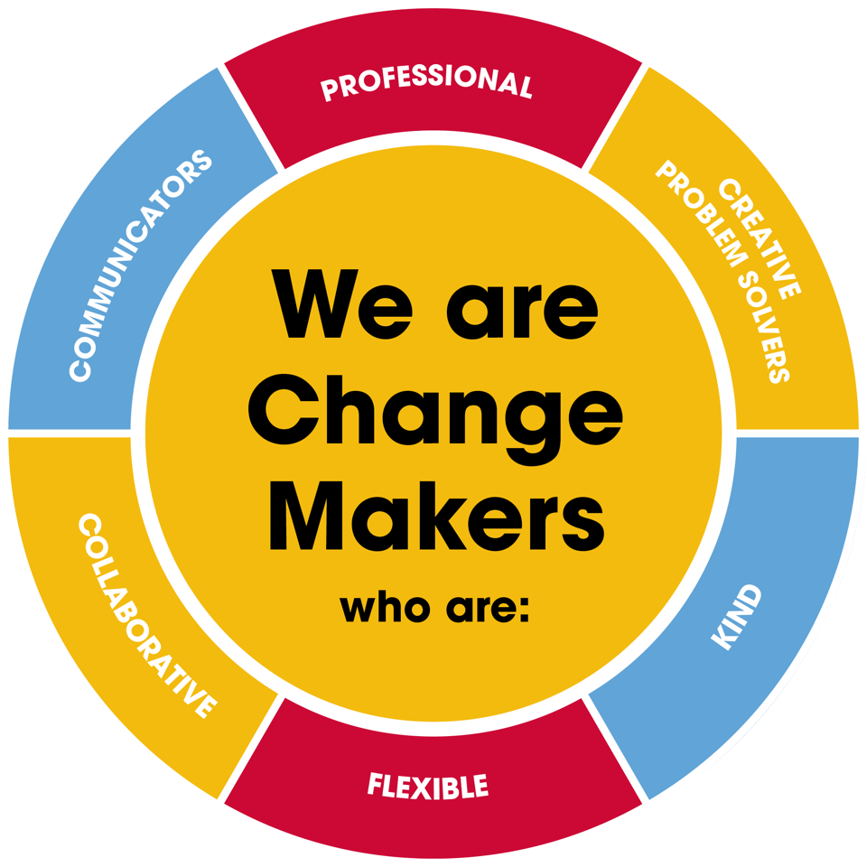
Value scales:
This value is the least important to the role | This value has some significance to the role | This value is desirable to the role but not essential | This value is important to the role | This value is essential to the role
1 | 2 | 3 | 4 | 5

In the role of VMT - Harp we are looking for Change Makers who are (please highlight as appropriate):

Professional: | 1 | 2 | 3 | 4 | 5
Creative Problem Solvers: | 1 | 2 | 3 | 4 | 5
Kind: | 1 | 2 | 3 | 4 | 5
Flexible: | 1 | 2 | 3 | 4 | 5
Collaborative: | 1 | 2 | 3 | 4 | 5
Communicator: | 1 | 2 | 3 | 4 | 5

