Job Description

Job Title: | Games Coach
Hours of Work: | 23.5 hours per week / 0.5FTE
Department: | Sport
Job Grade (if applicable): | n/a
Accountable to: | Dir of Sport / Head of Boys’/Girls’ Games
Number of direct reports: | none
Budgetary responsibility: | none
Location: | Winchester House School, Brackley
Purpose of the role: | Y3-8 Sports Coach  Boys: Rugby, Hockey & Cricket  and/or  Girls: Hockey, Netball & Cricket
The Stowe Group
The Stowe Group of schools (Stowe, Swanbourne House, Ashfold and Winchester House) was created in January 2021 and is situated on three separate sites in Buckinghamshire and Northamptonshire. Across the three schools, The Stowe Group offers education for boys and girls from 3-18 years. Within The Stowe Group there are more than 1,500 pupils and 850 colleagues. The Schools occupy sites of historical significance in Swanbourne, the market town of Brackley and the world-famous landscape gardens at Stowe, where we work with The National Trust to manage 880 acres and open the grounds to over 200,000 visitors a year. Stowe House is open to the public during the School holidays and for guided tours during term time. The Stowe Group is committed to safeguarding and promoting the welfare of children and expects all staff to share this commitment. In 2021, The Stowe Group launched its transformational and substantive Change Makers vision and Change 100 programme.

Vision & Ethos
We are Change Makers

Our goal is to inspire pupils and staff to be Change Makers who will shape positive futures for themselves, their families and the global community. Our World-class facilities support our educational aims and are shared with the wider community. We strive for excellence and celebrate achievement, valuing education as a journey and not a destination in the belief that all pupils can exceed their potential. Learning is learnable and everyone can improve. Our aim is to encourage personal development by creating a flourishing, vibrant, cohesive, caring and socially inclusive community which embraces pluralism, diversity and intercultural understanding. We celebrate differences by giving everyone a voice and then listening to multiple viewpoints. It is our collective responsibility to develop the cognitive, physical, emotional and spiritual well-being of everyone in our community. We are committed to the development of character with particular emphasis on tolerance, resilience, honesty, humility, courage, compassion, gratitude and service. We strive to attract and retain employees of the highest calibre.

The Group’s talented and committed workforce is one of our greatest strengths. We are committed to fostering team engagement, attracting, mentoring, developing and retaining our best teachers and support staff. We focus on employee well-being, provide opportunities for professional growth and create a culture of community and partnership. Environmental stewardship and sustainability are cornerstones of The Stowe Group.

Pupils and staff have a heightened awareness of their social and environmental responsibility in preserving our unique eco-system. We have developed and implemented a comprehensive Environmental Stewardship Programme which confronts a variety of challenges, including climate change and environmental sustainability.
Key Tasks:
Duties
- To promote the aims of the School at all times with colleagues, parents, pupils and the public.

- To provide good quality teaching and coaching, with the effective use of appropriate resources to deliver the highest standards and achievements for all pupils.

- Deliver Sports Coaching to pupils in Year 3-8.
Boys: Rugby, Hockey & Cricket
and/or
Girls: Hockey, Netball & Cricket

- Input into team selection and de-selection.
- Input into the regular reviews of schemes of learning.
- Write termly reports for the children you teach.
- Communicate effectively with pupils, colleagues and parents.
- Work with the Director of Sport and Head of Boys’/Girls’ Games to identify and nurture any potential scholarship pupils.
- Ensure all pupils, whatever their ability and even when ‘off games’, partake in games and make progress. Give feedback appropriately.
- Provide an enriching co-curricular sporting provision during activities and boarding hours, with a particular reference to the development of Sports at WHS.

Health and Safety
- Adhere to the relevant Health and Safety Policies.
- Write/input to risk assessments as appropriate.
- To maintain good order and discipline among pupils and safeguarding their health and safety both on the School premises and when they are engaged in School and other activities elsewhere, within the framework of the Health and Safety Policy documents.

Person Specification: The selection of candidates for short-listing will be based on this specification and candidates should bear this in mind when preparing their application and completing the application form
Attributes | Essential | Desirable
Qualifications | - Level two coaching qualification OR QTS (or working towards). | A valid first aid certificate.
Specialist Skills and Experience | - Experience coaching at least two of our major games- rugby, hockey and cricket. | Experience coaching one of our major sports at club or county level.
Personal Qualities | - Effective communication.  - Solution orientated.  - Strong planning and organisational skills.  - Able to work independently and as part of a team.  - A can do attitude.  - To be committed to safeguarding and promoting the welfare of children.
This job description and Person Specification reflects the present requirements of the post and as duties and responsibilities change/develop, the job description will be reviewed and be subject to amendment in consultation with the post holder
Date Agreed: June 2026

Our Values
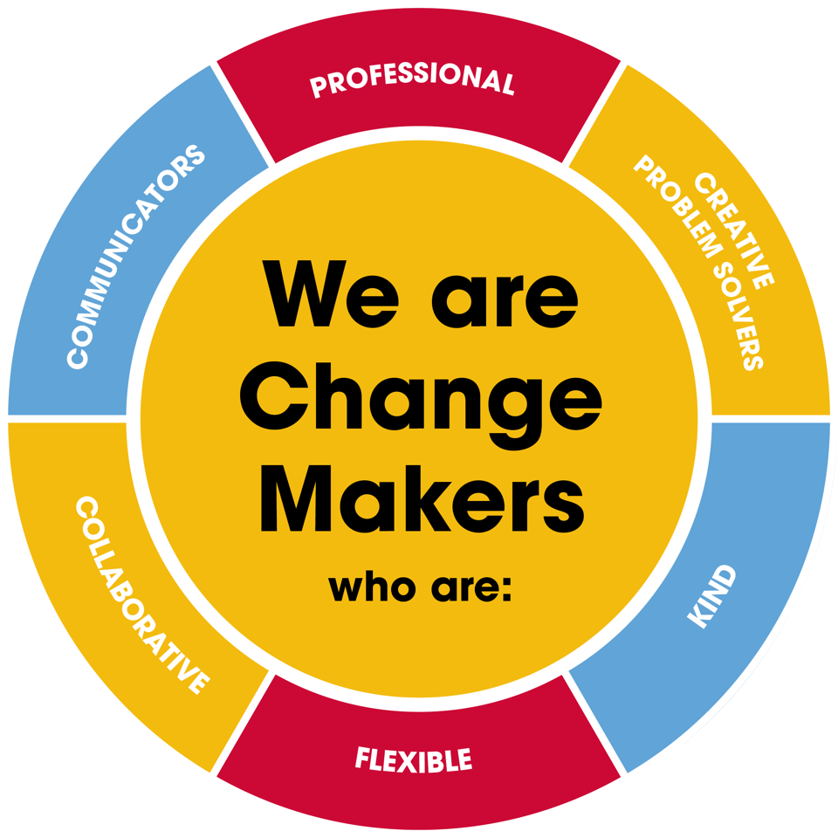
Value scales:
This value is the least important to the role | This value has some significance to the role | This value is desirable to the role but not essential | This value is important to the role | This value is essential to the role
1 | 2 | 3 | 4 | 5

In this role we are looking for Change Makers who are (please highlight as appropriate):

Professional: | 1 | 2 | 3 | 4 | 5
Creative Problem Solvers: | 1 | 2 | 3 | 4 | 5
Kind: | 1 | 2 | 3 | 4 | 5
Flexible: | 1 | 2 | 3 | 4 | 5
Collaborative: | 1 | 2 | 3 | 4 | 5
Communicator: | 1 | 2 | 3 | 4 | 5

