Job Description

Job Title: | Pupil Administrator & PA to the Senior Deputy Head
Hours of Work: | 8:30am – 4:30pm Monday to Friday, term time Plus 3 weeks (37 weeks) The nature of the role does require flexibility in working hours
Department: | Senior Deputy Heads Office
Job Grade (if applicable): | Grade 6
Accountable to: | Senior Deputy Head
Number of direct reports: | N/A
Budgetary responsibility: | N/A
Location: | Stowe School
Purpose of the role: | To act as Pupil Administrator; collating information relevant to individual pupils, year groups and the whole School roll and to assist the Senior Deputy Head in his day-to-day role; organising his diary and coordinating the paperwork required to carry out the wide spectrum of responsibilities of the Senior Deputy Head).
The Stowe Group
The Stowe Group of schools (Stowe, Ashfold, Swanbourne House and Winchester House) is situated on four separate sites in Buckinghamshire and Northamptonshire and educates children from 3-18 years. Within The Stowe Group there are more than 1,800 pupils and 800 members of staff. The schools occupy sites of historical significance in Swanbourne, Dorton, Brackley and the world-famous landscape gardens at Stowe, where we work with The National Trust to manage 880 acres and open the grounds to over 200,000 visitors a year. Stowe House is open to the public during the School holidays and for guided tours during term time. The Stowe Group is committed to safeguarding and promoting the welfare of children and expects all staff to share this commitment. In 2021, The Stowe Group launched its transformational Change Makers vision and Change 100 programme.

Vision & Ethos
We are Change Makers

Stowe stands in the most sublime setting of any school in the world. Historic buildings, landscaped gardens and the very spirit of the Enlightenment sit at the heart of its founding. But, as this remarkable landmark enters its second century as a leading public school, we believe that beauty and tradition are not enough: our future vision for the School embraces change, uncertainty and the challenges that will face our pupils not just during their academic careers, but throughout the rest of their lives in a world which is increasingly complex and ambiguous. Within that volatile environment we see our pupils and staff as Change Makers. They will make a lasting impact not only while they are here at Stowe, but, perhaps more importantly, in the wider world. The history of this place, both as a stately home and as a pioneering school remains important to our mission of education, and at the heart of a Stowe education remains intellectual enquiry, academic curiosity and a love of learning. We strive for a balance of rights and responsibilities, equality and inclusion and to treat each pupil and member of staff as an individual. Our vision is inspired by a history of progressive thinking, and has been developed through collaboration with our pupils, parents, teachers, support staff, governors and alumni. Yes, we teach pupils how to excel in exams, but we also teach them how to collaborate, how to solve problems and how to think critically. Stowe is educating a generation of Change Makers ready to transform the world.

The Group’s talented and committed workforce is one of our greatest strengths. We are committed to fostering team engagement, attracting, mentoring, developing and retaining our best teachers and support staff. We focus on employee wellbeing, provide opportunities for professional growth and we create a culture of community and partnership.
Key Tasks:
General:
- To provide administrative support for correspondence, distributing letters and notices for parents, pupils and staff (using the ISAMS database).

- Electronic diary and email monitoring and management using MS Office, including booking and arranging meetings and highlighting any important email correspondence.

- To act as a point of contact for the Senior Deputy Head, dealing with enquiries and taking messages.

- To prepare meeting schedules, agendas, organise refreshments and take minutes at meetings as required.

- To collate any complaints or concerns and ensure they are brought to the attention of the Senior Deputy Head and responded to in a timely manner.

- Collate overseas visits requests and present them for approval to the Senior Deputy Head and respond to the applicant in a timely manner.

- To monitor the school rules and procedures as published in the Blue Book.

- Filing and document management, ensuring all relevant files are up to date.

- To process and publish the daily Sanctions list.

- To assist in the administration of the weekly staff duty list.

- To assist in the production of tailored Suspension Reintegration Contracts.

- To work with the Finance Department and parents to collate consent for Stowebucks membership
Daily Tasks
- Issue the daily sanctions list by 10.00am.
- Check and chase missing registers at 9.00am and 2.15pm.
- Update the weekly bulletin as required.
- Prepare the weekly bulletin for publication.

Weekly Tasks
- Publish weekly attendance statistics.
- Produce weekly bullying reports.
- Produce weekly discipline reports.
- Analyse Microsoft 365 data relating to:
  - Attendance
  - Bullying
  - Discipline

- Prepare Notes from the Common Room meetings.
- Assist with administration of the weekly staff duty list.
- Send the completed duty list to the Senior Deputy Head.
- Issue Saturday sanctions by 10.00am Friday.

Pupil Administration Tasks:
- To update ISAMS to reflect Pupils’ contact details, attendance, disciplinary records and other relevant data.
- To assist with the upkeep of allocations and pupil lists including:-
        - Weekly staff duty lists
        - Daily sanctions list
        - Organisational details for School events
        - Daily bulletins
        - Stowebucks club drinks lists

- To prepare letters confirming pupil attendance at the school.
- To assist with the administration of attendance records and absence requests.
- To assist with the preparation and archiving of new pupil files and leavers’ files.
- To carry out other ad hoc duties relating to current pupils.
- To update pupil spreadsheets.
- To liaise with Admissions, Finance and ICT departments on pupil records.
- To help with the organisation of pupil and attendance filing.

Person Specification: The selection of candidates for short-listing will be based on this specification and candidates should bear this in mind when preparing their application and completing the application form
Attributes | Essential | Desirable
Qualifications |  | - Degree  - Safeguarding Trained
Specialist Skills and Experience | - Excellent organisational skills  - A keen eye for detail  - Ability to prioritise and to work quickly and accurately  - Excellent communication and interpersonal skills  - Strong IT Skills, especially in data management and reporting | - Comprehensive knowledge of safeguarding  - Experience working with young people  - Advanced proficiency on Microsoft Office products – Word, Excel and Outlook
Personal Qualities | - Capable of independent thought and willing to accept responsibility.  - Approachable but able to be assertive  - Flexible in approach, adaptable and open to new ideas.  - Intuitive, resourceful and discreet.  - Remaining calm under pressure  - Possessing determination, drive, stamina and enthusiasm.  - Willing to consult, seek advice when appropriate and learn from experience.
This job description and Person Specification reflects the present requirements of the post and as duties and responsibilities change/develop, the job description will be reviewed and be subject to amendment in consultation with the post holder
Date Agreed: July 2026

Our Values
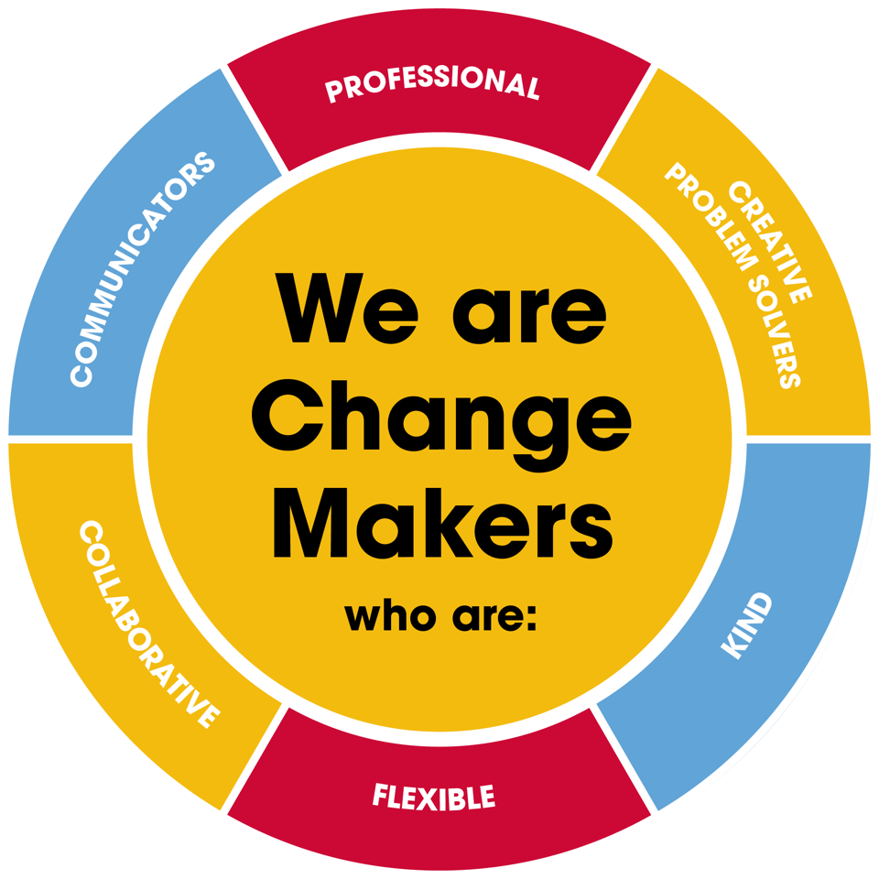
Value scales:
This value is the least important to the role | This value has some significance to the role | This value is desirable to the role but not essential | This value is important to the role | This value is essential to the role
1 | 2 | 3 | 4 | 5

In the role of Pupil Administrator and PA to the Senior Deputy Head we are looking for Change Makers who are (please highlight as appropriate):

Professional: | 1 | 2 | 3 | 4 | 5
Creative Problem Solvers: | 1 | 2 | 3 | 4 | 5
Kind: | 1 | 2 | 3 | 4 | 5
Flexible: | 1 | 2 | 3 | 4 | 5
Collaborative: | 1 | 2 | 3 | 4 | 5
Communicator: | 1 | 2 | 3 | 4 | 5

