Job Description

Job Title: | Mini Winnies Plus Leader
Hours of Work: | Monday to Friday, 4:30pm – 6:30pm
Department: | Bradshaw
Job Grade (if applicable):
Accountable to: | Deputy Head (Head of Pre-Prep)
Number of direct reports:
Budgetary responsibility: | None
Location: | Winchester House School
Purpose of the role: | Have responsibility for planning, organising and monitoring the activities of children in our after-school programme for the Pre-Prep.
The Stowe Group
The Stowe Group of schools (Stowe, Ashfold, Swanbourne House and Winchester House) is situated on four separate sites in Buckinghamshire and Northamptonshire and educates children from 3-18 years. Within The Stowe Group there are more than 1,800 pupils and 800 members of staff. The schools occupy sites of historical significance in Swanbourne, Dorton, Brackley and the world-famous landscape gardens at Stowe, where we work with The National Trust to manage 880 acres and open the grounds to over 200,000 visitors a year. Stowe House is open to the public during the School holidays and for guided tours during term time. The Stowe Group is committed to safeguarding and promoting the welfare of children and expects all staff to share this commitment. In 2021, The Stowe Group launched its transformational Change Makers vision and Change 100 programme.

Vision & Ethos
We are Change Makers

Our goal is to inspire pupils and staff to be Change Makers who will shape positive futures for themselves, their families and the global community. Our World-class facilities support our educational aims and are shared with the wider community. We strive for excellence and celebrate achievement, valuing education as a journey and not a destination in the belief that all pupils can exceed their potential. Learning is learnable and everyone can improve. Our aim is to encourage personal development by creating a flourishing, vibrant, cohesive, caring and socially inclusive community which embraces pluralism, diversity and intercultural understanding. We celebrate differences by giving everyone a voice and then listening to multiple viewpoints. It is our collective responsibility to develop the cognitive, physical, emotional and spiritual well-being of everyone in our community. We are committed to the development of character with particular emphasis on tolerance, resilience, honesty, humility, courage, compassion, gratitude and service. We strive to attract and retain employees of the highest calibre.

The Group’s talented and committed workforce is one of our greatest strengths. We are committed to fostering team engagement, attracting, mentoring, developing and retaining our best teachers and support staff. We focus on employee well-being, provide opportunities for professional growth and create a culture of community and partnership. Environmental stewardship and sustainability are cornerstones of The Stowe Group.

Pupils and staff have a heightened awareness of their social and environmental responsibility in preserving our unique eco-system. We have developed and implemented a comprehensive Environmental Stewardship Programme which confronts a variety of challenges, including climate change and environmental sustainability.

Key Tasks:
- Monitor and interact with children in creative, artistic and physical activities
- Ensure the programme of activities meet the needs of the children attending
- Monitor children to ensure their health, safety and physical well-being; perform routine First Aid and enforce and ensure health and safety rules and procedures are observed.
- Maintain good discipline and pupil behaviour
- Maintain a clean and organised environment for pupils and ensure it is left tidily at 6.30pm; demonstrate and involve children in cleaning and organising the activities areas before, during, and after use.
- Take registers and complete other low-level record keeping as required, liaising with the Pre-Prep School Administrator as necessary.
- Follow policies such as the Collections Policy and Fire Policy to ensure our children’s wellbeing
- Assist children as required with their personal hygiene routines
- Liaise professionally with parents/carers at collection times
- Work with the other members of Mini Winnies Club Plus staff to ensure quality provision
- Monitor provision and feedback to the Head of Pre-Prep
- Ensure that hygiene standards and manners are observed during their hot tea provision and monitor the children are eating a satisfactory amount of food to feedback to parents
- Liaise and assist with catering staff as necessary and ensure all allergies are catered for

Person Specification: The selection of candidates for short-listing will be based on this specification and candidates should bear this in mind when preparing their application and completing the application form
Attributes | Essential | Desirable
Qualifications | - A minimum of a relevant level 3 Early Years Qualification  - Good written and spoken Literacy skills Be ICT literate  - Paediatric First Aid Qualification | - understanding of the importance of Health & Safety and Food Hygiene in the workplace
Specialist Skills and Experience | - working in an educational setting or co-ordinating activities for children  - preparing practical, differentiated resources including games, apparatus and visual aids  - utilise a range of strategies to promote good behaviour | - Teaching children aged 3-7  - an area of particular expertise or interest that would enhance the extra-curricular programme  - Evidence of continuous commitment to further professional development  - Experience in supporting children with SEND
Personal Qualities | - Excellent communication at all levels  - work constructively as part of a team,  - inspire the children  - create a happy, safe, well organised and stimulating environment  - be reflective and learn from past experiences and be willing to accept advice and support from colleagues
This job description and Person Specification reflects the present requirements of the post and as duties and responsibilities change/develop, the job description will be reviewed and be subject to amendment in consultation with the post holder
Date Agreed: May 2026

Our Values
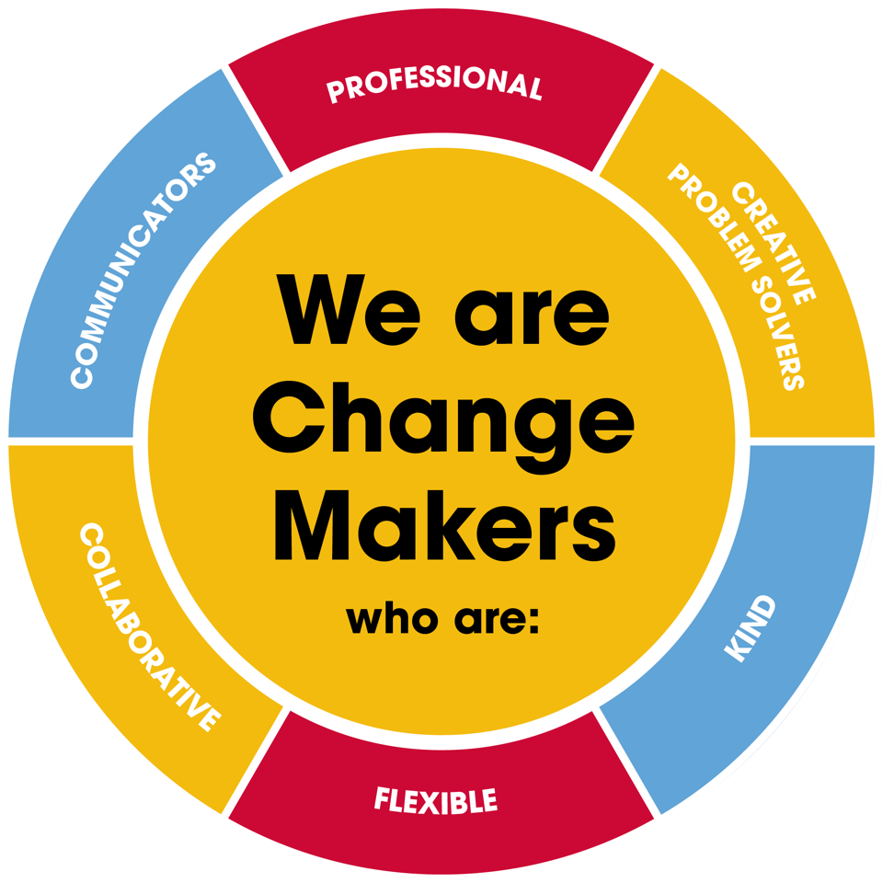
Value scales:
This value is the least important to the role | This value has some significance to the role | This value is desirable to the role but not essential | This value is important to the role | This value is essential to the role
1 | 2 | 3 | 4 | 5

In the role of Minnie Winnies Leader we are looking for Change Makers who are (please highlight as appropriate):

Professional: | 1 | 2 | 3 | 4 | 5
Creative Problem Solvers: | 1 | 2 | 3 | 4 | 5
Kind: | 1 | 2 | 3 | 4 | 5
Flexible: | 1 | 2 | 3 | 4 | 5
Collaborative: | 1 | 2 | 3 | 4 | 5
Communicator: | 1 | 2 | 3 | 4 | 5

