Job Description

Job Title: | Wrap-Around Care Supervisor
Hours of Work: | Monday to Friday 3.30pm - 7.00pm (Term Time 34 weeks)
Department: | Lower School
Job Grade: | 7
Accountable to: | Head of Lower School
Number of direct reports: | 0
Budgetary responsibility: | N/A
Location: | Swanbourne House School
Purpose of the role: | To support the delivery of a safe, caring and stimulating wrap around care programme for children in EYFS and KS1.
The Stowe Group
The Stowe Group of schools (Stowe, Ashfold, Swanbourne House and Winchester House) is situated on four separate sites in Buckinghamshire and Northamptonshire and educates children from 3-18 years. Within The Stowe Group there are more than 1,800 pupils and 800 members of staff. The schools occupy sites of historical significance in Swanbourne, Dorton, Brackley and the world-famous landscape gardens at Stowe, where we work with The National Trust to manage 880 acres and open the grounds to over 200,000 visitors a year. Stowe House is open to the public during the School holidays and for guided tours during term time. The Stowe Group is committed to safeguarding and promoting the welfare of children and expects all staff to share this commitment. In 2021, The Stowe Group launched its transformational Change Makers vision and Change 100 programme.

Vision & Ethos
We are Change Makers

Our goal is to inspire pupils and staff to be Change Makers who will shape positive futures for themselves, their families and the global community. Our World-class facilities support our educational aims and are shared with the wider community. We strive for excellence and celebrate achievement, valuing education as a journey and not a destination in the belief that all pupils can exceed their potential. Learning is learnable and everyone can improve. Our aim is to encourage personal development by creating a flourishing, vibrant, cohesive, caring and socially inclusive community which embraces pluralism, diversity and intercultural understanding. We celebrate differences by giving everyone a voice and then listening to multiple viewpoints. It is our collective responsibility to develop the cognitive, physical, emotional and spiritual well-being of everyone in our community. We are committed to the development of character with particular emphasis on tolerance, resilience, honesty, humility, courage, compassion, gratitude and service. We strive to attract and retain employees of the highest calibre.

The Group’s talented and committed workforce is one of our greatest strengths. We are committed to fostering team engagement, attracting, mentoring, developing and retaining our best teachers and support staff. We focus on employee well-being, provide opportunities for professional growth and create a culture of community and partnership. Environmental stewardship and sustainability are cornerstones of The Stowe Group.

Pupils and staff have a heightened awareness of their social and environmental responsibility in preserving our unique eco-system. We have developed and implemented a comprehensive Environmental Stewardship Programme which confronts a variety of challenges, including climate change and environmental sustainability.
Key Tasks:
- Provide a welcoming, nurturing environment where children feel happy and secure.
- Prepare and serve light meals, sandwiches, and snacks, ensuring dietary needs and allergies are catered for.
- Supervise children during play, activities and mealtimes, encouraging positive behaviour and social interaction.
- Uphold school standards by following all policies and procedures, including safeguarding and health & safety.
- Work effectively as part of a team, supporting colleagues and maintaining good communication.
- Be flexible within the daily routines of the provision, helping where needed (e.g. tidying, setting up activities, cleaning equipment).
- Liaise with parents/carers at drop-off and collection, providing friendly and supportive communication.
- Ensure children are safely signed in and out, and collected by known adults.
- Record and report any accidents, incidents or safeguarding concerns in line with school procedures.
- Respect the confidentiality of all information relating to children, families and staff.

Childcare and Supervision Tasks:

- Prepare age-appropriate activities that promote play, creativity and social development.
- Support children with their personal needs (e.g. toileting, handwashing, putting on coats).
- Provide comfort and reassurance to any child who is upset or unwell.
- Promote good table manners and encourage a calm, social atmosphere at snack and mealtimes.
- Ensure the environment is inclusive, safe and welcoming to all children, respecting different cultures, religions and backgrounds.
- Remain vigilant to the needs and wellbeing of all children at all times.
- To actively promote and support the safeguarding of children and young people in the workplace, ensuring policies and procedures are observed at all times.

Person Specification: The selection of candidates for short-listing will be based on this specification and candidates should bear this in mind when preparing their application and completing the application form
Attributes | Essential | Desirable
Qualifications | - Completion of a recognised Level 2 Childcare qualification, e.g. Level 2 Certificate for the Children & Young People’s Workforce or Children’s Care, Learning and Development – or be working towards completion  - A positive approach to completing relevant short courses and qualifications | - Some understanding of the importance of Health & Safety and Food Hygiene in the workplace  - Paediatric first aid trained
Specialist Skills and Experience | - Enthusiasm for working with young children  - An interest in the care, learning and development of young children  - A commitment to the provision of high-quality childcare  - A positive approach to learning and gaining new skills through teamwork and training opportunities  - An understanding of the Early Learning Goals and National Curriculum | - Previous experience of caring for, or working with children in a voluntary or paid capacity
Personal Qualities | - Good organisational, record keeping and planning skills  - Punctuality  - Excellent communication skills, with children, colleagues, advisors and parents/carers.  - Patience  - Reliability and trustworthiness  - A positive approach to inclusive practice, with children and colleagues  - Flexibility
This job description and Person Specification reflects the present requirements of the post and as duties and responsibilities change/develop, the job description will be reviewed and be subject to amendment in consultation with the post holder
Date Agreed: January 2025

Our Values
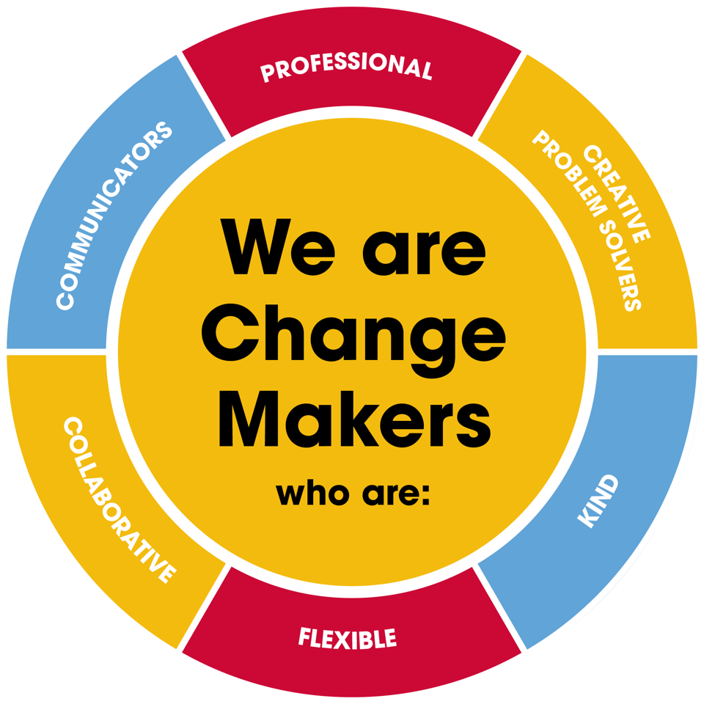
Value scales:
This value is the least important to the role | This value has some significance to the role | This value is desirable to the role but not essential | This value is important to the role | This value is essential to the role
1 | 2 | 3 | 4 | 5

In the role of Wrap-Around Care Supervisor we are looking for Change Makers who are (please highlight as appropriate):

Professional: | 1 | 2 | 3 | 4 | 5
Creative Problem Solvers: | 1 | 2 | 3 | 4 | 5
Kind: | 1 | 2 | 3 | 4 | 5
Flexible: | 1 | 2 | 3 | 4 | 5
Collaborative: | 1 | 2 | 3 | 4 | 5
Communicator: | 1 | 2 | 3 | 4 | 5

