Job Description

Job Title: | Housestaff (Full Time)
Hours of Work: | Monday to Friday and working alternate weekends (with day off given in the week)
Department: | Operations
Job Grade | 7
Accountable to: | Head of Housestaff and Security
Number of direct reports: | No direct reports
Budgetary responsibility: | n/a
Location: | Stowe School
Purpose of the role: | To work within a team providing an efficient service to standards set by the School for cleaning and furniture movement.
The Stowe Group
The Stowe Group of schools (Stowe, Swanbourne House and Winchester House) was created in January 2021 and is situated on three separate sites in Buckinghamshire and Northamptonshire. Across the three schools, The Stowe Group offers education for boys and girls from 3-18 years. Within The Stowe Group there are more than 1,500 pupils and 850 colleagues. The Schools occupy sites of historical significance in Swanbourne, the market town of Brackley and the world-famous landscape gardens at Stowe, where we work with The National Trust to manage 880 acres and open the grounds to over 200,000 visitors a year. Stowe House is open to the public during the School holidays and for guided tours during term time. The Stowe Group is committed to safeguarding and promoting the welfare of children and expects all staff to share this commitment. In 2021, The Stowe Group launched its transformational and substantive Change Makers vision and Change 100 programme.
Vision & Ethos
We are Change Makers

Stowe stands in the most sublime setting of any school in the world. Historic buildings, landscaped gardens and the very spirit of the Enlightenment sit at the heart of its founding. But, as this remarkable landmark enters its second century as a leading public school, we believe that beauty and tradition are not enough: our future vision for the School embraces change, uncertainty and the challenges that will face our pupils not just during their academic careers, but throughout the rest of their lives in a world which is increasingly complex and ambiguous. Within that volatile environment we see our pupils and staff as Change Makers. They will make a lasting impact not only while they are here at Stowe, but, perhaps more importantly, in the wider world. The history of this place, both as a stately home and as a pioneering school remains important to our mission of education, and at the heart of a Stowe education remains intellectual enquiry, academic curiosity and a love of learning. We strive for a balance of rights and responsibilities, equality and inclusion and to treat each pupil and member of staff as an individual. Our vision is inspired by a history of progressive thinking, and has been developed through collaboration with our pupils, parents, teachers, support staff, governors and alumni. Yes, we teach pupils how to excel in exams, but we also teach them how to collaborate, how to solve problems and how to think critically. Stowe is educating a generation of Change Makers ready to transform the world.

The Group’s talented and committed workforce is one of our greatest strengths. We are committed to fostering team engagement, attracting, mentoring, developing and retaining our best teachers and support staff. We focus on employee wellbeing, provide opportunities for professional growth and we create a culture of community and partnership.
Key Tasks:
- To provide a cleaning service within the classrooms, main state rooms and public areas.
- To assist in the setting up and clearing down of functions.
- To follow priorities of workload to ensure that deadlines are met.
- To ensure that cleaning standards are met as laid down by the Deputy Head of Housestaff.
- To provide a customer-based service that enhances the image of the School, keeping the Head of House and Security apprised of changing events and circumstances within the School, which would affect the function and efficiency of the Housestaff.
- To confirm Health and Safety legislation and to be aware around the school of Health and Safety infringements, reporting incidents to the Deputy Head of Housestaff.
- To carry out any related duty when requested by the Deputy Head of Housestaff.
- To ensure adherence to statutory Health and Safety and Data Protection Legislation at all times.

Person Specification: The selection of candidates for short-listing will be based on this specification and candidates should bear this in mind when preparing their application and completing the application form
Attributes | Essential | Desirable
Qualifications | - Current driving licence | - Current first aid certificate
Specialist Skills and Experience | - A past team history of working within a team  - High standards of cleaning  - A general knowledge of Health and Safety  - Ability to follow instructions precisely.  - Excellent customer service skills. | - Experience of working within a School environment  - Knowledge of COSHH/Manual Handling
Personal Qualities | - An enthusiastic and positive attitude towards work, with a willingness to learn and undertake training.  - Able to work on own initiative or with others on tasks with minimum supervision.  - Integrity.
This job description and Person Specification reflects the present requirements of the post and as duties and responsibilities change/develop, the job description will be reviewed and be subject to amendment in consultation with the post holder
Date Agreed: March 2025

Our Values
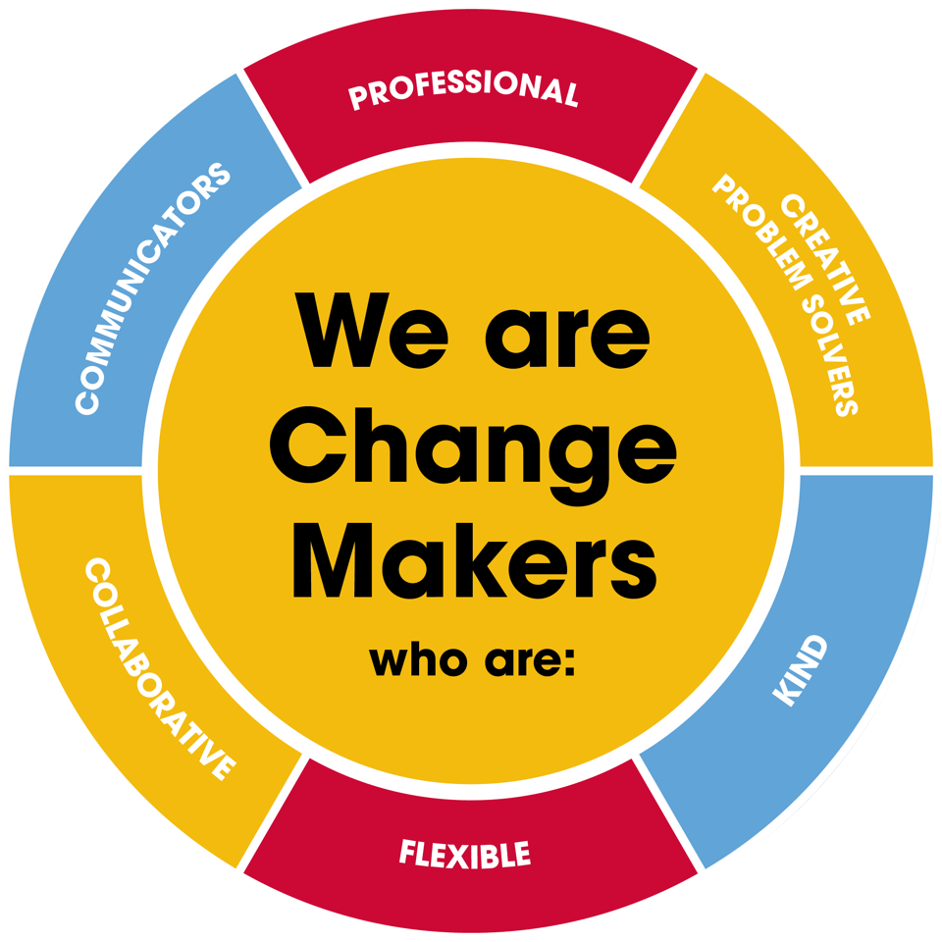

Value scales:
This value is the least important to the role | This value has some significance to the role | This value is desirable to the role but not essential | This value is important to the role | This value is essential to the role
1 | 2 | 3 | 4 | 5

In the role of Housestaff we are looking for Change Makers who are (please highlight as appropriate):

Professional: | 1 | 2 | 3 | 4 | 5
Creative Problem Solvers: | 1 | 2 | 3 | 4 | 5
Kind: | 1 | 2 | 3 | 4 | 5
Flexible: | 1 | 2 | 3 | 4 | 5
Collaborative: | 1 | 2 | 3 | 4 | 5
Communicator: | 1 | 2 | 3 | 4 | 5

