Job Description

Job Title: | Minibus Driver
Hours of Work: | 6.30am-8.30am (Monday to Friday) & 6.15pm – 8.15pm (Mon, Tue, Thurs, Fri)
Department: | Operations
Job Grade (if applicable): | 8
Accountable to: | Director of Operations
Number of direct reports: | 0
Budgetary responsibility: | N/A
Location: | Winchester House
Purpose of the role: | We are looking for a reliable and trustworthy minibus driver to join our Transport Team. This individual will be tasked with providing and friendly and efficient service to our families who require transport to and from school.  The Minibus Driver would be responsible for transporting students on our Home to School service, additional hours helping with transport for school visits and sporting fixtures may also be available.
The Stowe Group
The Stowe Group of schools (Stowe, Ashfold, Swanbourne House and Winchester House) was created in January 2021 and is situated on four separate sites in Buckinghamshire and Northamptonshire. Across the three schools, The Stowe Group offers education for boys and girls from 3-18 years. Within The Stowe Group there are more than 1,800 pupils and 850 colleagues. The Schools occupy sites of historical significance in Swanbourne, Dorton, the market town of Brackley and the world-famous landscape gardens at Stowe, where we work with The National Trust to manage 880 acres and open the grounds to over 200,000 visitors a year. Stowe House is open to the public during the School holidays and for guided tours during term time. The Stowe Group is committed to safeguarding and promoting the welfare of children and expects all staff to share this commitment. In 2021, The Stowe Group launched its transformational and substantive Change Makers vision and Change 100 programme.

Vision & Ethos
We are Change Makers

Our goal is to inspire pupils and staff to be Change Makers who will shape positive futures for themselves, their families and the global community. Our World-class facilities support our educational aims and are shared with the wider community. We strive for excellence and celebrate achievement, valuing education as a journey and not a destination in the belief that all pupils can exceed their potential. Learning is learnable and everyone can improve. Our aim is to encourage personal development by creating a flourishing, vibrant, cohesive, caring and socially inclusive community which embraces pluralism, diversity and intercultural understanding. We celebrate differences by giving everyone a voice and then listening to multiple viewpoints. It is our collective responsibility to develop the cognitive, physical, emotional and spiritual well-being of everyone in our community. We are committed to the development of character with particular emphasis on tolerance, resilience, honesty, humility, courage, compassion, gratitude and service. We strive to attract and retain employees of the highest calibre.

The Group’s talented and committed workforce is one of our greatest strengths. We are committed to fostering team engagement, attracting, mentoring, developing and retaining our best teachers and support staff. We focus on employee well-being, provide opportunities for professional growth and create a culture of community and partnership. Environmental stewardship and sustainability are cornerstones of The Stowe Group.

Pupils and staff have a heightened awareness of their social and environmental responsibility in preserving our unique eco-system. We have developed and implemented a comprehensive Environmental Stewardship Programme which confronts a variety of challenges, including climate change and environmental sustainability.
Key Tasks:
Safety:
- Ensure Safety of Passengers, informing the Transport Manager immediately of any hazards, defects, non-compliance of Health and safety regulations or PCV Compliance regulations including any threat to the wellbeing of any students or staff
- To transport staff and students on Home to School routes as per the route register and other locations as required
- Ensure parents, students and staff are treated with politeness and courtesy. Always being a good ambassador for the school.

Compliance
- To observe the current legislation and vehicle licensing laws
- To maintain and provide proper records as required using the system outlined by the school

Maintenance
- To maintain the minibus by keeping it tidy and cleaned on a daily/ weekly basis or as requested.

Other
- Ability to adapt to change in situations
- To undertake any training as required
- To be flexible to work when required, with reasonable notice

Safeguarding
- To comply with safeguarding policies, procedures, and code of conduct
- To demonstrate a personal commitment to safeguarding and student/ college wellbeing
- To ensure that any safeguarding concerns or incidents are reported appropriately in line with policy
- To engage in safeguarding training when required.

Person Specification: The selection of candidates for short-listing will be based on this specification and candidates should bear this in mind when preparing their application and completing the application form
Attributes | Essential | Desirable
Qualifications | - Hold a full manual UK driving licence for a minimum of 24 months  - Good levels of written and spoken English | - Hold a D1 PCV category licence without 101 restriction code or full category D PCV with not more than 3 points
Specialist Skills and Experience | - Excellent written and verbal communication skills, with the ability to construct and adapt appropriate communications to both children and adults  - Attention to detail  - Understanding of the importance of confidentiality | - Experience in passenger carrying vehicles  - Experience with home to school transportation  - Understanding of EU Driver Hours and WTD regulations
Personal Qualities | - Exemplary levels of confidentiality and professionalism  - Well- presented appearance and professional manner | - Enhanced DBS Check
This job description and Person Specification reflects the present requirements of the post and as duties and responsibilities change/develop, the job description will be reviewed and be subject to amendment in consultation with the post holder
Date Agreed: October 2025

Our Values
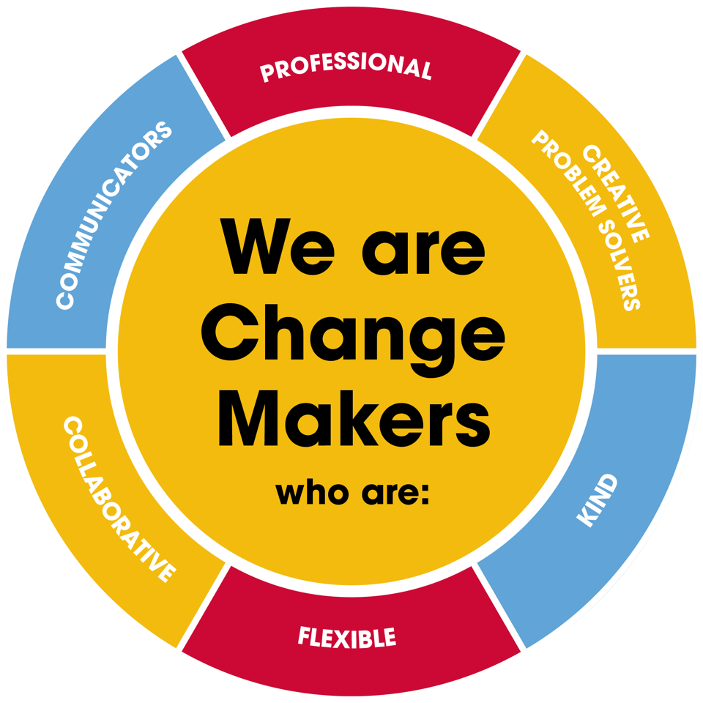
Value scales:
This value is the least important to the role | This value has some significance to the role | This value is desirable to the role but not essential | This value is important to the role | This value is essential to the role
1 | 2 | 3 | 4 | 5

In the role of Minibus Driver we are looking for Change Makers who are (please highlight as appropriate):

Professional: | 1 | 2 | 3 | 4 | 5
Creative Problem Solvers: | 1 | 2 | 3 | 4 | 5
Kind: | 1 | 2 | 3 | 4 | 5
Flexible: | 1 | 2 | 3 | 4 | 5
Collaborative: | 1 | 2 | 3 | 4 | 5
Communicator: | 1 | 2 | 3 | 4 | 5

